Using DOM on a Table
In this exercise you will experiment with using DOM properties and methods to switch between CSS files Exercises. You can find the solution and the required file for this exercise in the following folder:
H:\BUSINESS\DISC\6420 IWD\exercises\Using DOM on a Table\

Instructions

- Copy the code of “tableDom.html”. Then, write a function called appendRow() using DOM to append a new row in a different color at the end of the table (see Figure 2). The content of new row is taken from the user. You can use prompt (text, default) function to take the inputs from users.

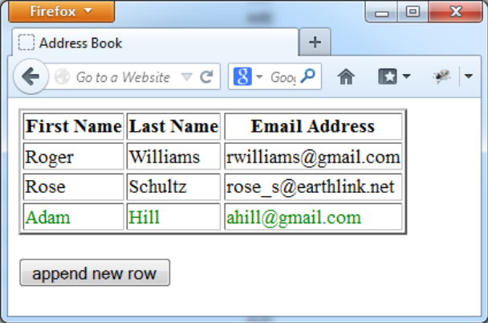
Figure 2 append new row

- Based on 1), add event handler to each row added, that when the user click a word, it will display the content of that word in bold text. When you click the same word again, it will be changed back to normal text (see Figure 3). Test your code both in Firefox and IE.
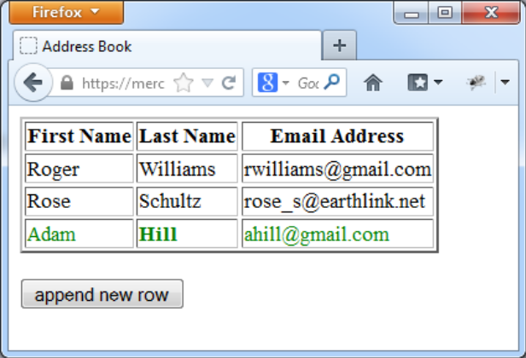
Figure 3 add event listener

- Based on 2), add event handler to handle mouse over event. When the mouse moves over the table, the font size of that field will be increased, and the background color will be changed. When the mouse moves out the content will be changed back to normal size and color(see Figure 4).

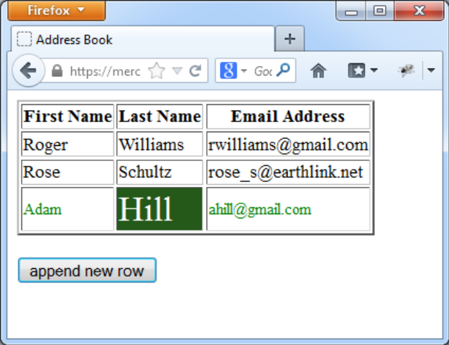
Figure 4 change font size/color when mouse over

